11. Using a terminal, connect to a remote machine via SSH and telnet

SSH:

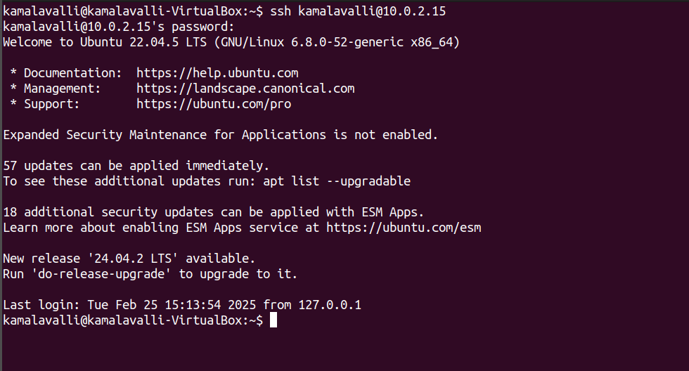

TELNET:

